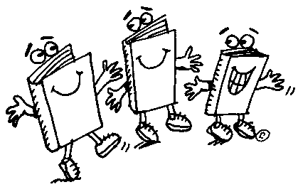Greenup County Reading Fair
2016-2017

The purpose of the competition is to provide students in grades K-12 the opportunity to share their favorite fictional book through a storyboard display. The implementation of the Common Core State Standards (CCSS) places an emphasis on students reading complex texts at grade level. CCSS also places value on reading non-fiction texts which increases student understanding of informational text. The goal of the reading fair is to enhance and encourage reading at all grade levels and to allow students to collaborate with their peers. The ultimate goal is that students will experience a deeper enjoyment from reading and develop a lifelong love of reading.
There will a competition at each school and first place winners in each division will proceed to the district competition.

Reading Fair Categories

Individual Fiction/Non-fiction

Division A Grades 2 & 3
Division B Grades 3 & 4
Division C Grades 5 & 6
Division D Grades 7 & 8
Division E Grades 9-12

Group/Family Fiction/Non-fiction

Division F Grades K & 1
Division G Grades 2 & 3
Division H Grades 4 & 5
Division I Grades 6-8
Division J Grades 9-12

Please read and follow all guidelines carefully to avoid disqualification.

Categories

Each student is limited to participating in only ONE project.
Family division projects should portray a book appropriate to the age of the student(s). The student(s) should be very knowledgeable about the book’s story elements and should have an active part in the construction of the display. Family and group categories will be judged more closely on whether the project shows work appropriate for the age level of the student.
Group projects are limited to a maximum of 3 participants.

Storyboards

Any size tri-fold will be accepted.

Display/Safety

1. Complete and attach the identifying information label (obtained from the teacher) to the back of the storyboard. Storyboards without labels will NOT be judged.
2. Storyboards should be colorful and interesting. Models, shadowboxes, and illustrations that fit in the middle of the display are allowed. The total project should not exceed the width, depth or height of the standing display board. There cannot be items protruding from the back or top of the board.
3. Items on the storyboard may be handwritten or typed. Younger students may require assistance in writing, typing, spelling, cutting, etc. This is permissible.
Storyboard content should match the age, grade level, and ability of the students presenting the project. The book must be displayed in the project at the District judging.
4. Electrical cords are not allowed at any level of competition.
5. No items should hang over the edge of the table or be placed on the floor. However, student may hold or wear items that coordinate with the project, if desired. Items used for the project are not to be alive, valuable, or dangerous.

TIES

One winner per category from each school will be sent to the District competition. In the event of a tie at the school competition, the school library media specialist will determine a tie breaker.

Awards

Students will receive medals for 1st, 2nd, and 3rd place at each school.
Gift cards will be awarded to all 1st place winners at the District competition.

Reading Fair Permission Form

Note: This form will also advance to the District Level competition.

Student’s Name___________________________________________________
(Please Print)

Parent/Guardian’s Name____________________________________________

School_______________________________________________

Title of Book______________________________________________

Select Category student will represent. (Check one category.)

Individual Group/Family
Fiction/Non-fiction _____ Fiction/Non-fiction_____

______________________________________________ _______________ Parent/Guardian Signature Date

